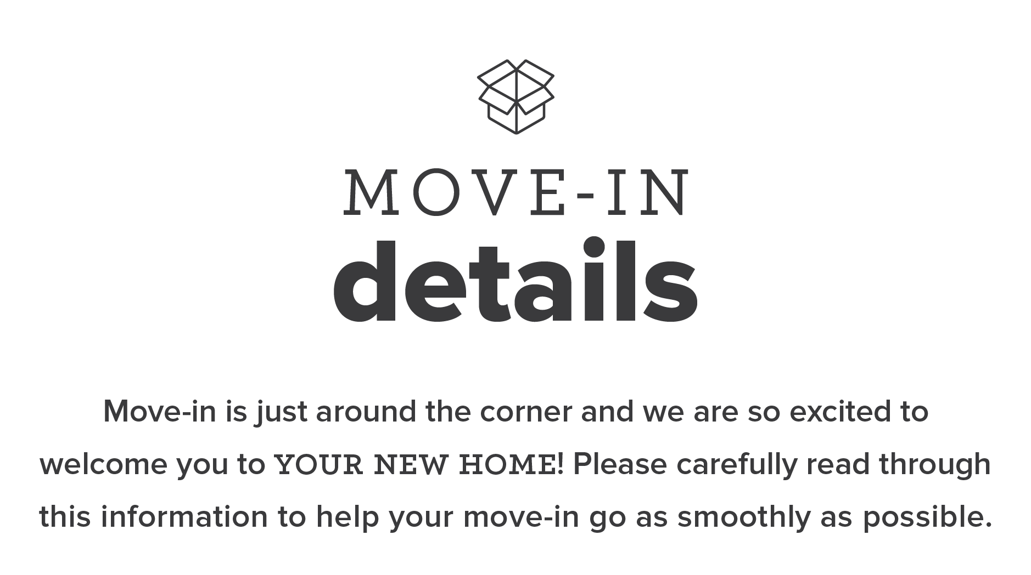

August 1, 2019 – August 24, 2019

There will be directional signage, as well as staff members available to assist you in locating your designated check-in area.

Also, out of respect to those moving in during their designated time, please do not attempt to move-in before your designated move-in time.

You should have received an email asking you to select your move in day. If you need to change your selected date or have not responded to the initial email, please call our office to let us know what day to expect you. This will help us make sure your move in process is smooth!
ALL of the following items must be completed before you move in. If any of these items are incomplete, you will not be able to receive your keys until it is resolved.

□ Lease Completed
□ Lease Signed
□ Applicable Addenda Signed
□ Guarantor Approved

□ $0 Balance
□ Admin Fee Paid (If Applicable)
□ August Rent Installment Paid
(Due on or before 8/1/2019)

□ Renter’s Insurance Suggested
See page 2 for renter’s insurance details.

□ Verizon Cable/Internet Activation Scheduled

*** For Fast Pass Check-in eligibility,

ALL checklist items must be completed
no later than five days prior to your selected
move in date. See page 2 for Fast Pass Check-In
details.

If everything on your Move-in Checklist is completed FIVE (5) days prior to your selected move in date, CONGRATULATIONS! You qualify for our Fast Pass Check-In. That means all you have to do is come up to our check-in station and pick up your keys – simple as that!

But remember those early birds we talked about? There’s a chance that even though you qualify for Fast Pass Check-in, you may still have a wait time to check in since there may be a lot of other “Fast Passers” arriving at the same time as you.

But the good news is that once you arrive to our check-in station we’ll have your keys in a jiffy because as a “Fast Pass” resident, there’s no paperwork to complete and no payments to collect!
Your first rent installment will be for August and is due on or before August 1, 2019.

Your lease payments are divided into 12 equal installments. Every month rent is due on the 1st of the month. We do offer (6) days of grace period in case you forget to get it in on the 1st, but as of the 7th of the month, rent will be considered late and a late fee will be charged. Unpaid late rent accrues additional fees daily until it is paid in full, so make sure to remember: DUE on the 1st, LATE on the 7th.

Rent payments must be submitted online through your Resident Portal account.

Renter’s insurance is highly suggested at move-in and for the duration of your lease. While we do not require Renter’s insurance, please note that management and ownership are not responsible for damage to your personal property due to flood, fire, or other maintenance issue. This includes other residents causing damage. Renter’s Insurance is your protection of your personal property.

STEP 1: MAKE SURE YOUR INSURANCE MEETS THIS CRITERIA:

□ Lists your name
□ Coverage for your specific address
at The Nest at 1324 (unit + bed space)
□ Coverage dates that coincide with your
lease term dates
□ The Nest at 1324 listed as an
additional interested party

STEP 2: Once you have acquired a policy that meets the criteria, please provide us with a copy of the declarations page. Typically, a declarations page contains all of the information, but you may need additional documentation.

STEP 3: KEEP YOUR POLICY ACTIVE. For the duration of your lease, you’ll want to have your renter’s insurance policy active. If at any time during your lease your policy “defaults,” it means you are not covered in case of an accident.
The Nest at 1324 is a pet-free building – even as a visitor!

We do accept Service Animals with approved documentation from a physician. If you are in need of a service animal, the documentation must be provided and approved by management PRIOR to the animal coming to the property.

Whether you bring them with you or buy them after you get a feel for the place, here are a few things to help make your house a home.

□ Bedroom
- Linens (full-size if unit is furnished)
- Curtains for Décor (window blinds provided)
Due to variance in floor plans, window dimensions are not available prior to move-in.

□ Bathroom (we provide a shower liner)
- Towels
- Toilet paper
- Toiletries (Shampoo, soap, etc.)

□ Kitchen
- Utensils
- Small appliances (coffee maker, toaster, etc.)
- Dishes, bowls and glassware
- Pots and pans

□ Electronics
- Gaming console
(or hang out in the community game room)
- Computer (we have a great study lounges too!)

□ Cleaning
- Vacuum and broom
- Laundry detergent
- Window cleaner & furniture polish
- Oh, the list goes on and on…

Remember to check with your roommate(s) to determine what items they are planning on bringing to avoid duplication in the common areas of your home.

